Output Screen Shot:

39110636

1. Write python code to find the Least Common Multiple among given two numbers

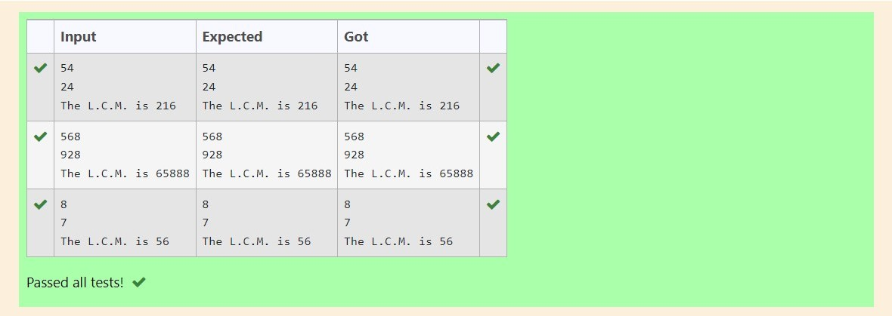

1. Evaluating the Results of Machine Learning Algorithms

Read Actual values Vs Predicted Values from the User.

Compute the following:

* 1. Confusion Matrix
  2. Accuracy
  3. Specificity
  4. Sensitivity
  5. Precision
  6. Recall
  7. Misclassification Error

